Group HW 1

2024-10-21

df = read.csv("oj_data.csv")

nrow(df)

## [1] 208

head(df, 15)

## Product_id Store_id Week Sales Price Holiday Display  
## 1 1 2 121 189 0.31   
## 2 1 2 122 111 0.33   
## 3 1 2 123 161 0.39   
## 4 1 2 124 108 0.39   
## 5 1 2 125 62 0.41   
## 6 1 2 126 93 0.35   
## 7 1 2 127 98 0.31   
## 8 1 2 128 1129 0.31   
## 9 1 2 129 181 0.33   
## 10 1 2 130 92 0.37   
## 11 1 2 131 303 0.31   
## 12 1 2 132 149 0.33   
## 13 1 2 133 83 0.36 Holiday   
## 14 1 2 134 227 0.30   
## 15 1 2 135 194 0.33

tail(df)

## Product_id Store_id Week Sales Price Holiday Display  
## 203 3 137 167 159 0.27   
## 204 3 137 168 389 0.23 Holiday   
## 205 3 137 169 1010 0.26   
## 206 3 137 170 543 0.27   
## 207 3 137 171 2224 0.15   
## 208 3 137 172 611 0.16 Holiday

#Plot the data  
plot(x = df$Sales, ## x-coordinates  
 y = df$Price, ## y-coordinates  
 type = "p", ## type of the graph ("p"= points, "l" = line)  
 cex=1, ## Size of the point   
 col = "black", ## color of the point  
 xlab = "Sales", ## label on x-axis  
 ylab = "Price", ## label on y-axis  
 main = "Raw Price-Sales plot")

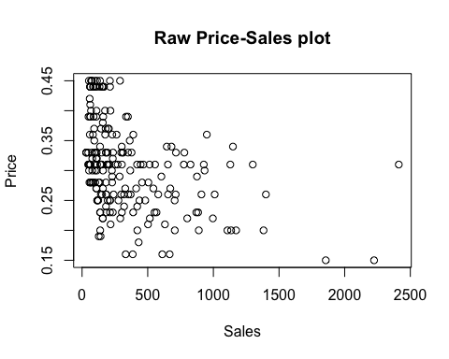

## Add logged variables to the data frame   
df$logSales = log(df$Sales)  
df$logPrice = log(df$Price)

#Plot the data  
plot(x = df$logSales, ## x-coordinates  
 y = df$logPrice, ## y-coordinates  
 type = "p", ## type of the graph ("p"= points, "l" = line)  
 cex=1, ## Size of the point   
 col = "black", ## color of the point  
 xlab = "Sales", ## label on x-axis  
 ylab = "Price", ## label on y-axis  
 main = "Raw Price-Sales plot")

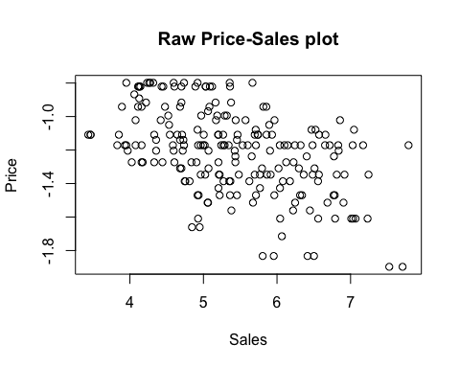

df$Display_cat= factor(df$Display) #Categorizing display variable  
df$Holiday_cat= factor(df$Holiday) #Categorizing display variable

## Now play with colors - Color by product  
plot(x = df$Sales,   
 y = df$Price,  
 type = "p", ## type of the graph ("p"= points, "l" = line)  
 cex = 1, ## shape of the point. filled circle   
 pch = 16, #filled circles  
 col = df$Display_cat, ## color will differ depending on whether there is a promotional display  
 xlab = "Sales", ## label on x-axis  
 ylab = "Price", ## label on y-axis  
 main = "In-aisle Display Effect")  
  
legend("topright", ### location of legend  
 legend = unique(df$Display_cat),  
 col=1:length(df$Display_cat),  
 pch=16)

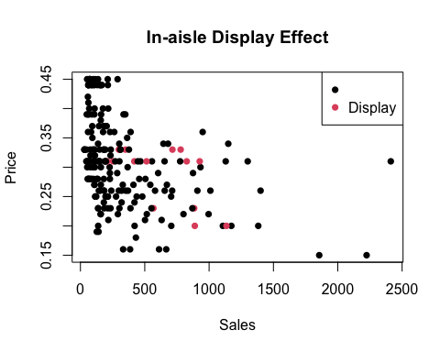

# Creating a numerical dummy variable  
#Making a display dummy variable  
df$DisplayDummy = 1*(df$Display == "Display")  
  
df$HolidayDummy = 1*(df$Holiday == "Holiday")

#Show the Store Effect  
df$Store_cat= factor(df$Store_id)  
## Now play with colors - Color by product  
plot(x = df$Sales,   
 y = df$Price,  
 type = "p", ## type of the graph ("p"= points, "l" = line)  
 cex = 1, ## shape of the point. filled circle   
 pch = 16, #filled circles  
 col = df$Store_cat, ## color will differ depending on whether there is a promotional display  
 xlab = "Sales", ## label on x-axis  
 ylab = "Price", ## label on y-axis  
 main = "Store Effect")  
legend("topright", ### location of legend  
 legend = unique(df$Store_cat),  
 col=1:length(df$Store_cat),  
 pch=16)

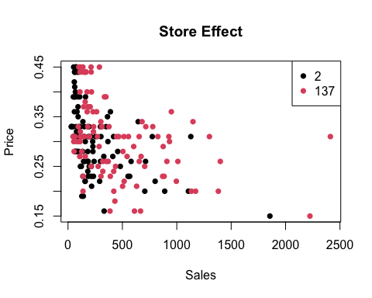

#Show the Product Effect  
df$Product_cat= factor(df$Product_id)  
## Now play with colors - Color by product  
plot(x = df$Sales,   
 y = df$Price,  
 type = "p", ## type of the graph ("p"= points, "l" = line)  
 cex = 1, ## shape of the point. filled circle   
 pch = 16, #filled circles  
 col = df$Product_cat, ## color will differ depending on whether there is a promotional display  
 xlab = "Sales", ## label on x-axis  
 ylab = "Price", ## label on y-axis  
 main = "Product Effect")  
legend("topright", ### location of legend  
 legend = unique(df$Product_cat),  
 col=1:length(df$Product_cat),  
 pch=16)

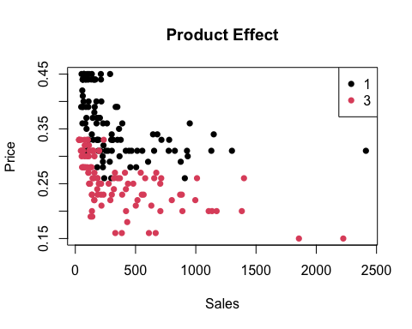

# visual inspection tells pricing is probably different for products - maybe premium and regular brands

## Make a dummy variable for store and product  
df$Product1 = 1*(df$Product_id == 1)  
df$Store2 = 1*(df$Store_id == 2)

## Question 1 and 2

df$Product1logPrice = df$Product1 * df$logPrice #interaction term with product dummy  
  
out_reg_hw = lm(logSales ~ logPrice + Product1logPrice + Product1 + Store2 + DisplayDummy + HolidayDummy, data=df)  
summary(out_reg_hw)

##   
## Call:  
## lm(formula = logSales ~ logPrice + Product1logPrice + Product1 +   
## Store2 + DisplayDummy + HolidayDummy, data = df)  
##   
## Residuals:  
## Min 1Q Median 3Q Max   
## -1.58222 -0.38231 -0.06522 0.29952 1.61680   
##   
## Coefficients:  
## Estimate Std. Error t value Pr(>|t|)   
## (Intercept) 1.28031 0.43259 2.960 0.003450 **   
## logPrice -3.24906 0.30696 -10.585 < 2e-16 ***  
## Product1logPrice -0.21527 0.48671 -0.442 0.658748   
## Product1 0.83374 0.58079 1.436 0.152691   
## Store2 -0.64772 0.08337 -7.770 3.97e-13 ***  
## DisplayDummy 0.61024 0.17217 3.544 0.000489 ***  
## HolidayDummy -0.38695 0.12354 -3.132 0.001994 **   
## ---  
## Signif. codes: 0 '***' 0.001 '**' 0.01 '*' 0.05 '.' 0.1 ' ' 1  
##   
## Residual standard error: 0.6005 on 201 degrees of freedom  
## Multiple R-squared: 0.6002, Adjusted R-squared: 0.5883   
## F-statistic: 50.3 on 6 and 201 DF, p-value: < 2.2e-16

## Question 3

demand_results_hw = out_reg_hw$coefficients # estimated coefficients from the model   
out_reg_hw$coefficients

## (Intercept) logPrice Product1logPrice Product1   
## 1.2803089 -3.2490640 -0.2152722 0.8337358   
## Store2 DisplayDummy HolidayDummy   
## -0.6477201 0.6102362 -0.3869468

demand_oj_hw = function(Price, Product1, Store2) {  
 ## demand function baesd on the regression results  
 ## Which equation does this refer to?  
 ## Which data variables is this function using?   
 Q = exp(demand_results_hw[1] + demand_results_hw[2]*log(Price) + demand_results_hw[3]*Product1*log(Price)+ demand_results_hw[4]*Product1 + demand_results_hw[5]*Store2)  
 Q[which(Q < 0)] = 0 # to make sure that demand is not negative  
 return(as.numeric(Q))  
}

# creating a vector of prices in increments of .001  
## plot predicted demand  
price_grid_hw = seq(  
 from = 0.1,  
 to = .5,   
 by = .001) ## create a grid of prices  
  
## what is the demand for these prices for Product 1 at Store 2  
demand_grid_hw = demand_oj_hw(price_grid_hw, 1, 1)

plot(x = price_grid_hw,   
 y = demand_grid_hw,   
 xlab = "Price",   
 ylab = "Quantity",   
 type ="l",# linetype. 1 = solid line. Default option is 1.   
 lty = 1,   
 main = "Demand functions") ## now type is line   
  
Price_p1s2 = df[df$Product1==1 & df$Store2 == 1 & df$HolidayDummy == 0 & df$DisplayDummy == 0,]$Price   
  
Sales_p1s2 = df[df$Product1==1 & df$Store2 == 1 & df$HolidayDummy == 0 & df$DisplayDummy == 0,]$Sales  
  
MeanPrice_p1s2 = mean(Price_p1s2)  
  
points(x = Price_p1s2, y = Sales_p1s2,lty=2,col="red",pch=19)  
  
abline(v=MeanPrice_p1s2, col="red")  
  
# Add a legend  
legend("topright", # Location of the legend  
 legend = c("Mean Price", "Actual Points"), # Text for the legend  
 col = c("red", "red"), # Colors of the lines and points  
 lty = c(1, NA), # Line type for the mean price (solid line)  
 pch = c(NA, 19), # Points for the actual data points  
 pt.cex = 1.5) # Size of the points in the legend

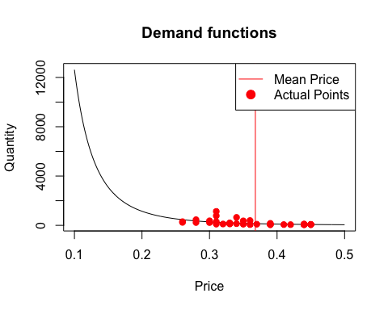 ##

Question 4

## Define profit function   
profit_oj_full <- function(Price, Product1, Store2, unit_cost, fixed_cost) {  
 quantity = demand_oj_hw(Price, Product1, Store2) ## compute the demand given price  
 profit = quantity * Price - quantity * unit_cost - fixed_cost ## compute profit  
 return(profit)  
}  
  
profit_grid = profit_oj_full(P = price_grid_hw,   
 Product1 = 1,   
 Store2 = 1,   
 unit_cost = .1,   
 fixed_cost = 0)  
  
df_profit <- data.frame(price_grid_hw, profit_grid)  
head(df_profit)

## price_grid_hw profit_grid  
## 1 0.100 0.00000  
## 2 0.101 12.19501  
## 3 0.102 23.57160  
## 4 0.103 34.18233  
## 5 0.104 44.07616  
## 6 0.105 53.29863

df_profit[which.max(df_profit$profit_grid),] #this returns 0.141 which is the max profit on the profit grid

## price_grid_hw profit_grid  
## 42 0.141 157.3952

## Plot the optimal price on the profit function graph   
plot(x = price_grid_hw,   
 y = profit_grid,   
 xlab = "Price",   
 ylab = "Profit",   
 type ="l",  
 main = "Profit function")  
  
abline(v = 0.141, ## x-intercept of the vertical line #profit maximizing price  
 lty = 2, ## linetype. 2 = dash   
 col = 'red')  
  
abline(v=MeanPrice_p1s2, col="red")  
  
legend("topright", # Location of the legend  
 legend = c("Profit Maximizing Price", "Mean Price"), # Text for the legend  
 col = "red", # Color for both lines  
 lty = c(2, 1), # Dashed line for profit-maximizing price, solid line for mean price  
 pt.cex = 1.5) # Size of the points in the legend

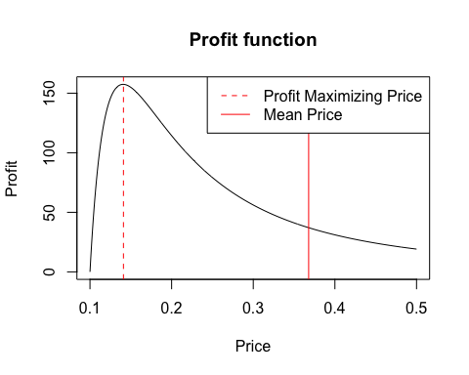

MeanPrice_p1s2 <- 0.368  
RecommendedPrice <- 0.141  
  
# profit for the mean price (0.368)  
mean_profit_row <- df_profit[which(df_profit$price_grid_hw == MeanPrice_p1s2), ]  
mean_profit <- mean_profit_row$profit_grid  
  
# Calculate the profit difference  
recommended_profit = 157.3952  
profit_difference <- recommended_profit - mean_profit  
  
# Output the profit difference  
print(profit_difference)

## [1] 120.3271

profit_grid2 = profit_oj_full(P = price_grid_hw,   
 Product1 = 1,   
 Store2 = 1,   
 unit_cost = .1,   
 fixed_cost = 25)  
  
df_profit2 <- data.frame(price_grid_hw, profit_grid2)  
head(df_profit2)

## price_grid_hw profit_grid2  
## 1 0.100 -25.000000  
## 2 0.101 -12.804988  
## 3 0.102 -1.428401  
## 4 0.103 9.182335  
## 5 0.104 19.076156  
## 6 0.105 28.298634

df_profit2[which.max(df_profit2$profit_grid2),]

## price_grid_hw profit_grid2  
## 42 0.141 132.3952

## Plot the optimal price on the profit function graph   
plot(x = price_grid_hw,   
 y = profit_grid,   
 xlab = "Price",   
 ylab = "Profit",   
 type ="l",  
 main = "Profit function")  
  
lines(x = price_grid_hw,   
 y = profit_grid2,   
 col = "green")  
  
abline(v = 0.141, ## x-intercept of the vertical line #profit maximizing price  
 lty = 2, ## linetype. 2 = dash   
 col = 'red')  
  
legend("topright",   
 legend = c("Profit without Fixed Cost", "Profit with Fixed Cost", "Optimal Price"),   
 col = c("black", "green", "red"),   
 lty = c(1, 1, 2),   
 cex = 0.8)

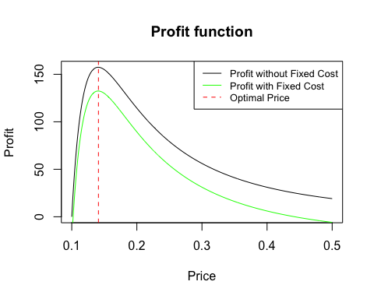

## question 5

profit_grid3 = profit_oj_full(P = price_grid_hw,   
 Product1 = 1,   
 Store2 = 1,   
 unit_cost = .2,   
 fixed_cost = 0)  
  
df_profit3 <- data.frame(price_grid_hw, profit_grid3)  
df_profit3[which.max(df_profit3$profit_grid3),]

## price_grid_hw profit_grid3  
## 182 0.281 28.52124

plot(x = price_grid_hw,   
 y = profit_grid3,   
 xlab = "Price",   
 ylab = "Profit",   
 type ="l",  
 main = "Profit function")  
  
abline(v = 0.281, ## x-intercept of the vertical line #profit maximizing price  
 lty = 2, ## linetype. 2 = dash   
 col = 'red')  
  
abline(v=MeanPrice_p1s2, col="red")  
  
legend("topright", # Location of the legend  
 legend = c("Profit Maximizing Price", "Mean Price"), # Labels  
 col = "red", # Color for both lines  
 lty = c(2, 1), # Dashed line for profit-maximizing price, solid line for mean price  
 pt.cex = 1.5)

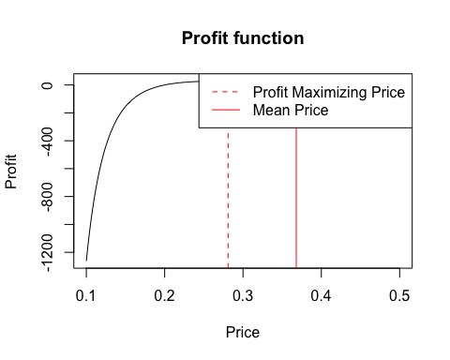

MeanPrice_p1s2 <- 0.368  
RecommendedPrice <- 0.281  
  
# profit for the mean price (0.368)  
mean_profit_row <- df_profit3[which(df_profit3$price_grid_hw == MeanPrice_p1s2), ]  
mean_profit <- mean_profit_row$profit_grid  
  
# Calculate the profit difference  
recommended_profit = 28.521  
profit_difference <- recommended_profit - mean_profit  
  
# Output the profit difference  
print(profit_difference)

## [1] 5.284265

profit_grid4 = profit_oj_full(P = price_grid_hw,   
 Product1 = 1,   
 Store2 = 1,   
 unit_cost = .2,   
 fixed_cost = 25)  
  
df_profit4 <- data.frame(price_grid_hw, profit_grid4)  
  
df_profit4[which.max(df_profit4$profit_grid4),]

## price_grid_hw profit_grid4  
## 182 0.281 3.521239

## Plot the optimal price on the profit function graph   
plot(x = price_grid_hw,   
 y = profit_grid3,   
 xlab = "Price",   
 ylab = "Profit",   
 type ="l",  
 main = "Profit function")  
  
lines(x = price_grid_hw,   
 y = profit_grid4,   
 col = "green")  
  
abline(v = 0.281, ## x-intercept of the vertical line #profit maximizing price  
 lty = 2, ## linetype. 2 = dash   
 col = 'red')  
  
legend("topright",   
 legend = c("Profit without Fixed Cost", "Profit with Fixed Cost", "Optimal Price"),   
 col = c("black", "green", "red"),   
 lty = c(1, 1, 2),   
 cex = 0.8)

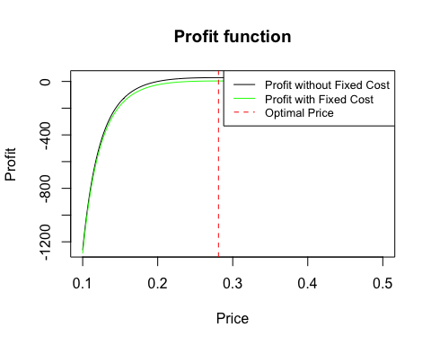 Optimal price is a function of price elasticity and marginal cost, and when the unit cost doubles, optimal price doubles as well. If the retailer is insistent on keeping the price same, as a manager, we will emphasis the risk of missing out on maximizing profits and will perhaps, show the above data driven approach, to drive home the point.